# Website Overview

This Chappy website is for administrative purposes only. It currently displays reports about Chaperones, Clients, Buildings and Open Transactions. Users are able to view reports containing all records or narrow into the detail of one specific record.

The website is located at:   
<http://chappyadmin.azurewebsites.net/>

## Construction

This site is an ASP.NET 5 Web Application built using Visual Studio 2015 and uses MVC to support the basic CRUD operations (create, read, update, delete). The site has been designed to be responsive, using Twitter Bootstrap, and the layout will adjust based on the user's device.

Since most tables have more columns than will fit on one screen in a smaller device, they have been made responsive as well. This allows the user to scroll horizontally through the table in order to view all fields and have only the table scroll, instead of the entire screen.

## Future Enhancements

The ability create, edit and deactivate record for all sections.

# Responsive Design Features

Menu changes when the device size is too small to legibly view the full-width menu.

## Branding

The Chappy logo is prominently displayed on the home page and a favicon add in order to easily locate the tab that Chappy is open on as well as to quickly locate in their bookmarks folder or bookmarks bar.

|  |  |
| --- | --- |
| C:\Users\Dell\Documents\GTC Fall 2015\CIST2931 - Advanced System Project\Documentation\Screenshots\Final JPEGs\Desktop.jpg |  |

## Responsive Menus

|  |  |
| --- | --- |
| C:\Users\Dell\Documents\GTC Fall 2015\CIST2931 - Advanced System Project\Documentation\Screenshots\Final JPEGs\Desktop.jpg | C:\Users\Dell\Documents\GTC Fall 2015\CIST2931 - Advanced System Project\Documentation\Screenshots\Final JPEGs\Responsive-Menu.jpg |

## Responsive Layout

|  |  |
| --- | --- |
| C:\Users\Dell\Documents\GTC Fall 2015\CIST2931 - Advanced System Project\Documentation\Screenshots\Final JPEGs\Desktop.jpg | C:\Users\Dell\Documents\GTC Fall 2015\CIST2931 - Advanced System Project\Documentation\Screenshots\Final JPEGs\Responsive-Layout.jpg |

# Responsive Tables

|  |  |  |
| --- | --- | --- |
| C:\Users\Dell\Documents\GTC Fall 2015\CIST2931 - Advanced System Project\Documentation\Screenshots\Final JPEGs\Responsive-Table-Design.jpg | https://truongtx.me/files/2013-04-11-simple-gesture-detection-for-libgdx/thumbnail.png | C:\Users\Dell\Documents\GTC Fall 2015\CIST2931 - Advanced System Project\Documentation\Screenshots\Final JPEGs\Responsive-Table-Design-Swiped.jpg |

# Screenshots

## Home

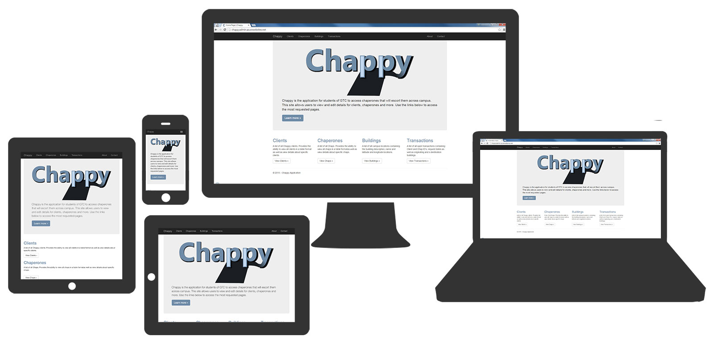

## About

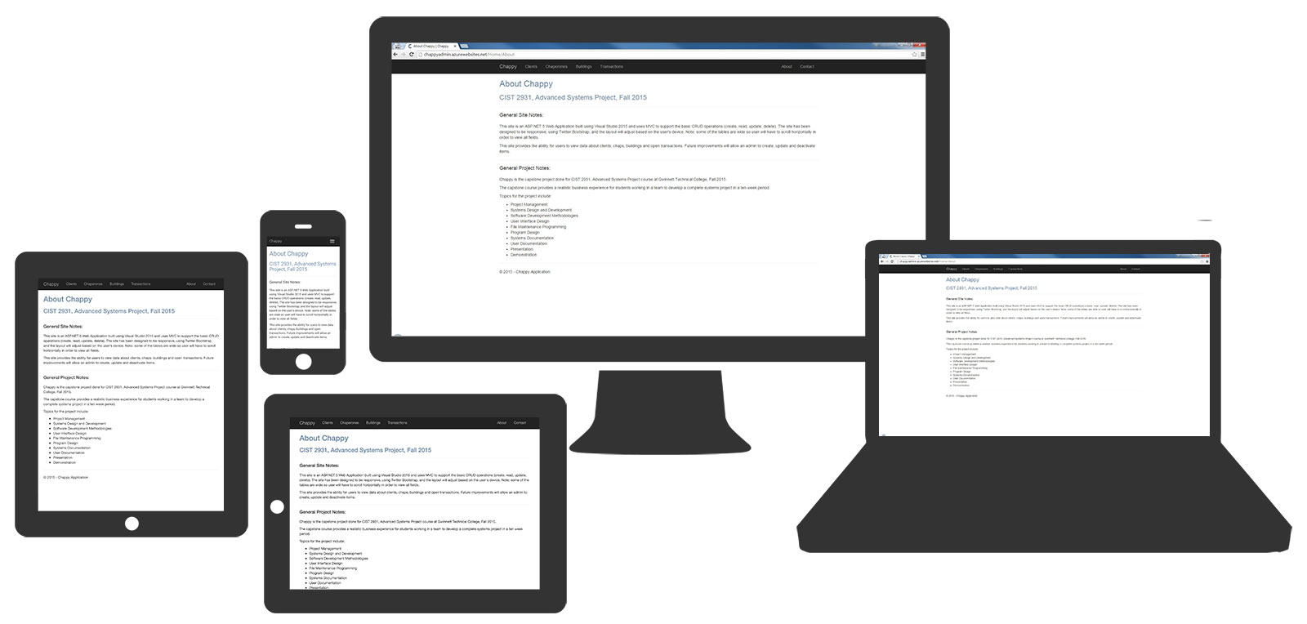

## Contact

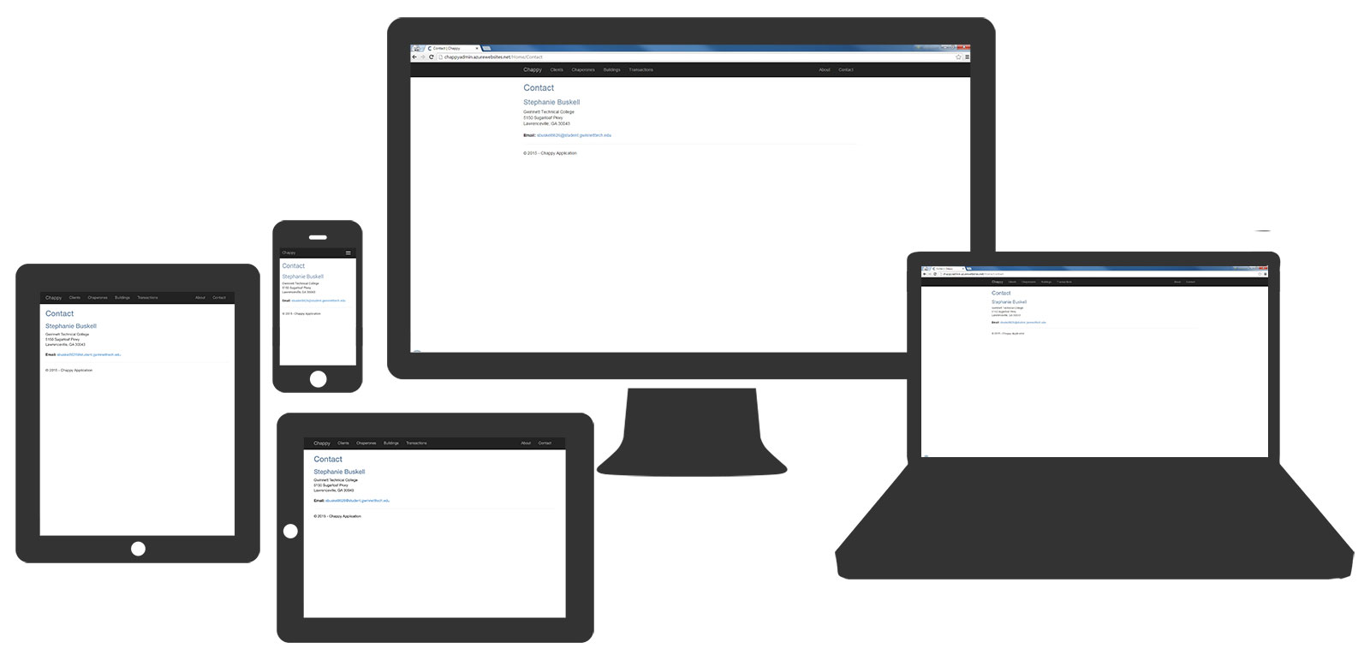

## Chaps

### All Chaps

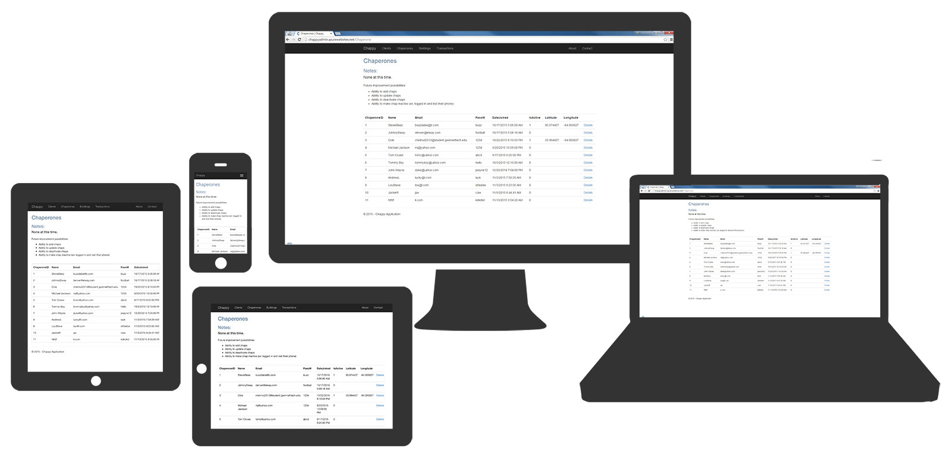

### Chap DetailsC:\Users\Dell\Documents\GTC Fall 2015\CIST2931 - Advanced System Project\Documentation\Screenshots\Final JPEGs\Chap-Details.jpg

## Clients

### All Clients

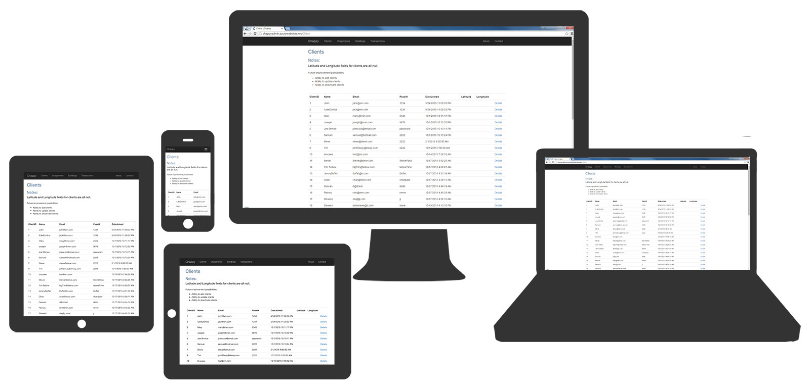

### Client Details

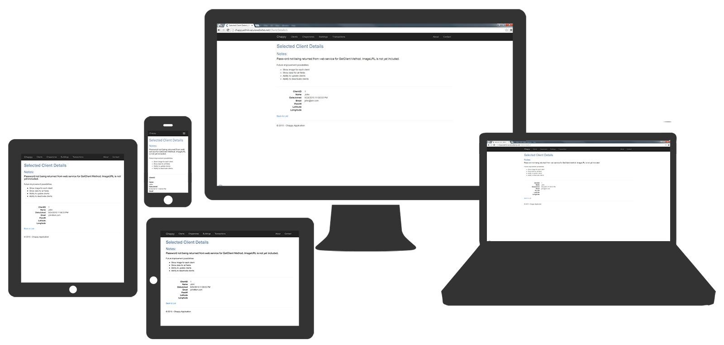

## Buildings

### All Buildings

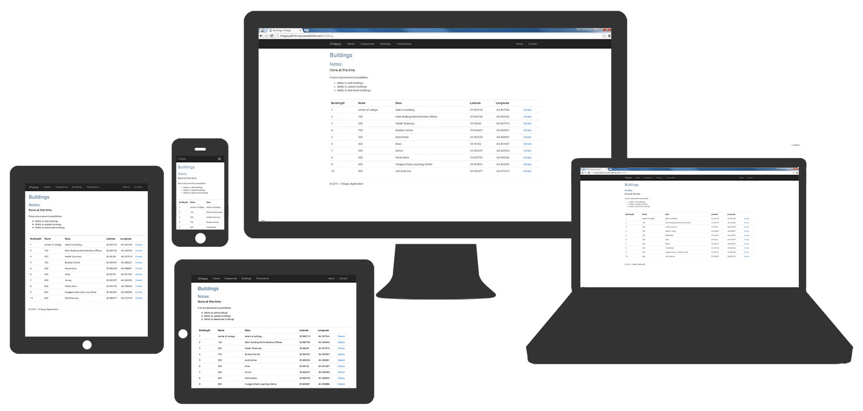

### Building Details

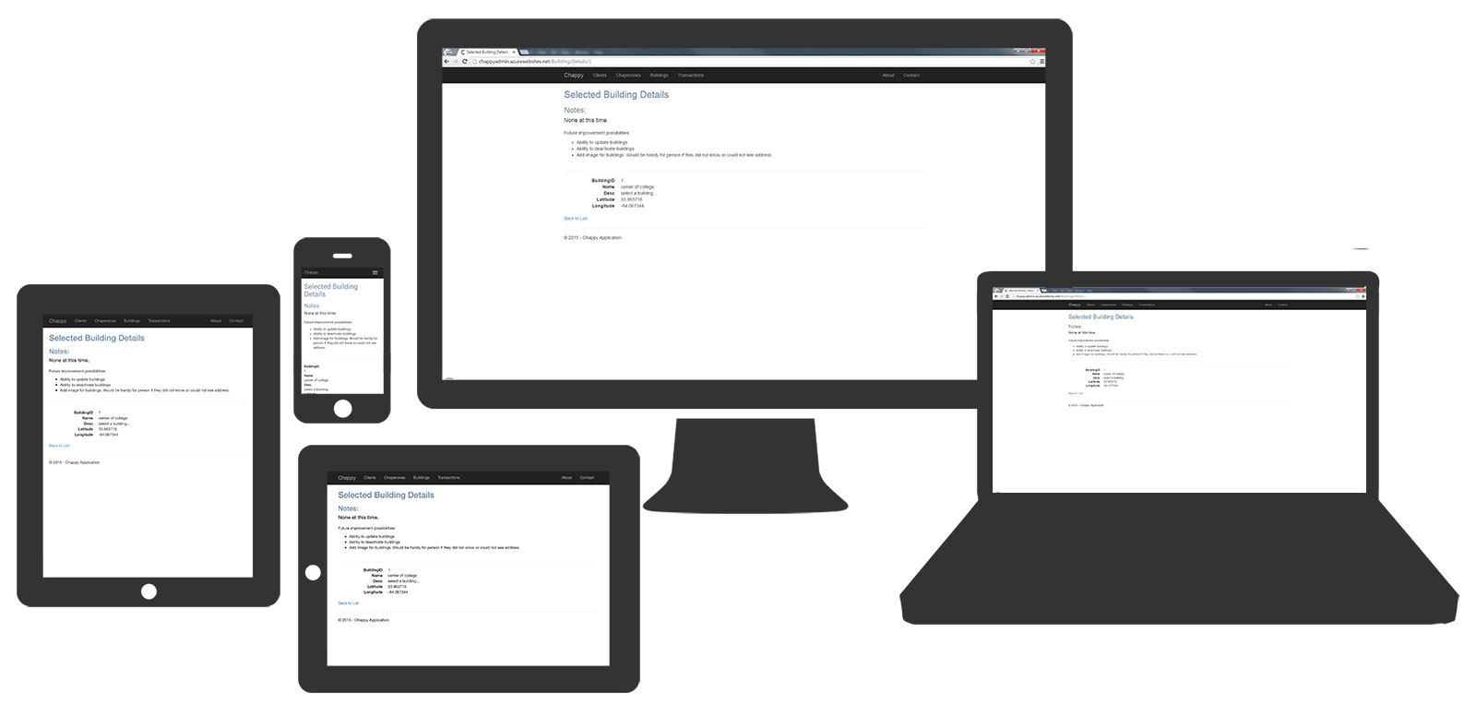

## Transactions

### All Open Transactions

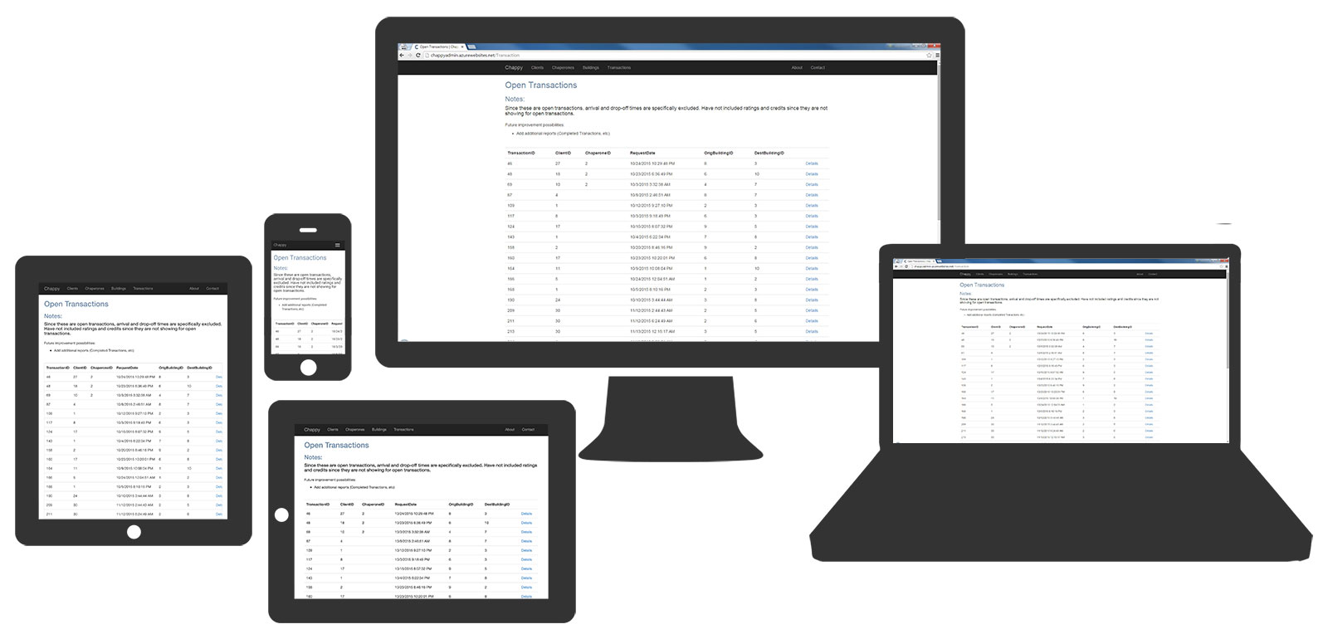

### Transaction Details

